**ONLINE FOOD ORDERING MANAGEMENT SYSTEM**

______________

A Thesis

Presented to the Faculty of the

College of Technology and Allied Sciences

BOHOL ISLAND STATE UNIVERSITY

Balilihan Campus, Magsija, Balilihan, Bohol

______________

In Partial Fulfillment

Of the Requirements of the Subjects

IT 211-Fundamentals of Database Systems

IT 212-Computer Programming(Java)

______________

Lilibeth C. Bacohod

Jafaith C. Batibot

Bea A. Sarong

December 2024

**TABLE OF CONTENTS**

**RATIONALE PAGES**

Introduction ………………………….…………….…………….…………….……… 1-2

Statement of the problem ……………………….……………….…………….……. 3-4

Flow Chart ……………………….…………….…………….…………….…….……. 5-17

Program Hierarchy ………………………………….…………….…………….……. 18-19

Screen Design ………………….…………….…………….…………….…………….20-29

**ONLINE FOOD ORDERING MANAGEMENT SYSTEM**

**RATIONALE**

**Introduction:**

Technology is transforming the food-ordering sector, making it more easy and efficient for both restaurants and customers. Online food ordering management systems use a variety of technology to streamline operations, improve customer experiences, and increase income. These systems enable customers to browse menus, place orders, and pay online, while restaurants can manage orders, track inventory, and analyze customer data to improve their offers and marketing tactics. The use of technology in online meal ordering management systems has altered the restaurant sector, providing a more seamless and modern way to order food.

Online Food Ordering Management Systems leverage technology to transform the foodservice industry, giving restaurants various advantages. These systems improve operations by automating order entry, processing, and delivery management, reducing manual labor and errors. Customers benefit from more convenience, specialized experiences, and real-time order tracking, which leads to increased happiness and loyalty. Furthermore, Online Food Ordering Management Systems provide restaurants with valuable consumer preference information, enabling them to run focused marketing campaigns and offer personalized incentives. This data-driven technique helps restaurants optimize menus, pricing, and marketing campaigns, resulting in greater sales and profitability. Combining Online Food Ordering Management Systems with other technologies, such as payment gateways, creates a unified platform for regulating restaurant operations, enhancing efficiency and customer satisfaction.

Restaurants have various problems when it comes to implementing an online food ordering management system. Technical challenges include assuring website and app functionality across several platforms, as well as handling order traffic during peak hours. It is critical to maintain food quality and consistency throughout the ordering, preparation, and delivery processes, as well as to respond quickly to customer complaints and feedback. Restaurants must also manage the intricacies of delivery logistics, such as coordinating with delivery staff and dealing with unexpected delays or glitches. Finally, developing brand recognition and effectively competing in a congested online economy necessitates intelligent marketing activities and a positive consumer experience. Overcoming these issues necessitates careful planning, technological investment, and a dedication to providing clients with a seamless and gratifying experience.

In order to make the process of placing and maintaining food orders more effective for both patrons and restaurant owners, we developed an online food ordering management system. Customers want speed and convenience in today’s fast-paced world, and our system offers an intuitive platform that lets users explore menus, personalize orders, and safely pay from the comfort of their homes. The technology provides restaurant owners with an effective management tool that allows them to improve customer service and streamline operations by tracking orders in real time, managing inventory, and analyzing consumer preferences. Our ultimate objective is to provide a smooth dining experience that satisfies the demands of contemporary customers while assisting small companies by bridging the gap between patrons and restaurants.

**Statement of the Problem:**

The rapid growth of the food delivery industry has resulted in a significant shift from traditional dining to online food ordering systems. While these systems provide convenience and efficiency for both customers and businesses, they are not without challenges and limitations. Many online food ordering management systems lack intuitive and user-friendly interfaces, making it difficult for customers to navigate the platform seamlessly. This often results in errors in order placement or a prolonged ordering process, which diminishes the overall user experience. Moreover, technical glitches, such as system crashes during peak hours, further frustrate users and lead to a loss of trust in the platform.

One of the critical challenges faced by these systems is the inefficiency in order tracking and management. Customers frequently complain about delayed deliveries, inaccurate updates on the status of their orders, or a lack of real-time notifications. This disconnect between customers, delivery personnel, and restaurants often leads to miscommunication and dissatisfaction. Additionally, the absence of advanced tracking systems can make it challenging for restaurant operators to monitor the progress of multiple orders simultaneously, further affecting service quality.

Security is another significant concern in existing food ordering platforms. Many systems fail to implement robust security measures to protect customer data, such as payment details and personal information. This vulnerability to data breaches and cyberattacks discourages customers from using the platform, thus impacting the business’s reputation. Furthermore, the integration of secure payment systems is often inadequate, resulting in failed transactions or difficulties in processing refunds, which can alienate both customers and restaurant operators.

Inventory management is also a recurring issue in online food ordering systems. Restaurants often struggle to keep their menus updated in real-time, leading to situations where customers place orders for items that are unavailable. This lack of synchronization between inventory systems and the online platform not only creates operational inefficiencies but also contributes to customer dissatisfaction.

Additionally, restaurants face challenges in handling high volumes of orders during peak times. Without efficient tools for prioritizing and organizing orders, delays and errors become inevitable. These operational inefficiencies negatively impact the restaurant’s ability to deliver quality service and maintain customer loyalty. Moreover, the absence of effective customer support mechanisms exacerbates these problems. Customers who encounter issues with their orders or the platform often struggle to get timely assistance, leading to frustration and a negative perception of the service.

Given these challenges, there is a pressing need to develop an improved online food ordering management system that addresses these gaps. The proposed solution must focus on enhancing user experience through intuitive interfaces, efficient order tracking, and real-time inventory updates. It should also prioritize security measures to protect customer data and integrate advanced tools for handling high order volumes. By addressing these issues, the system can improve operational efficiency, boost customer satisfaction, and foster loyalty, ultimately contributing to the growth and success of food delivery businesses.

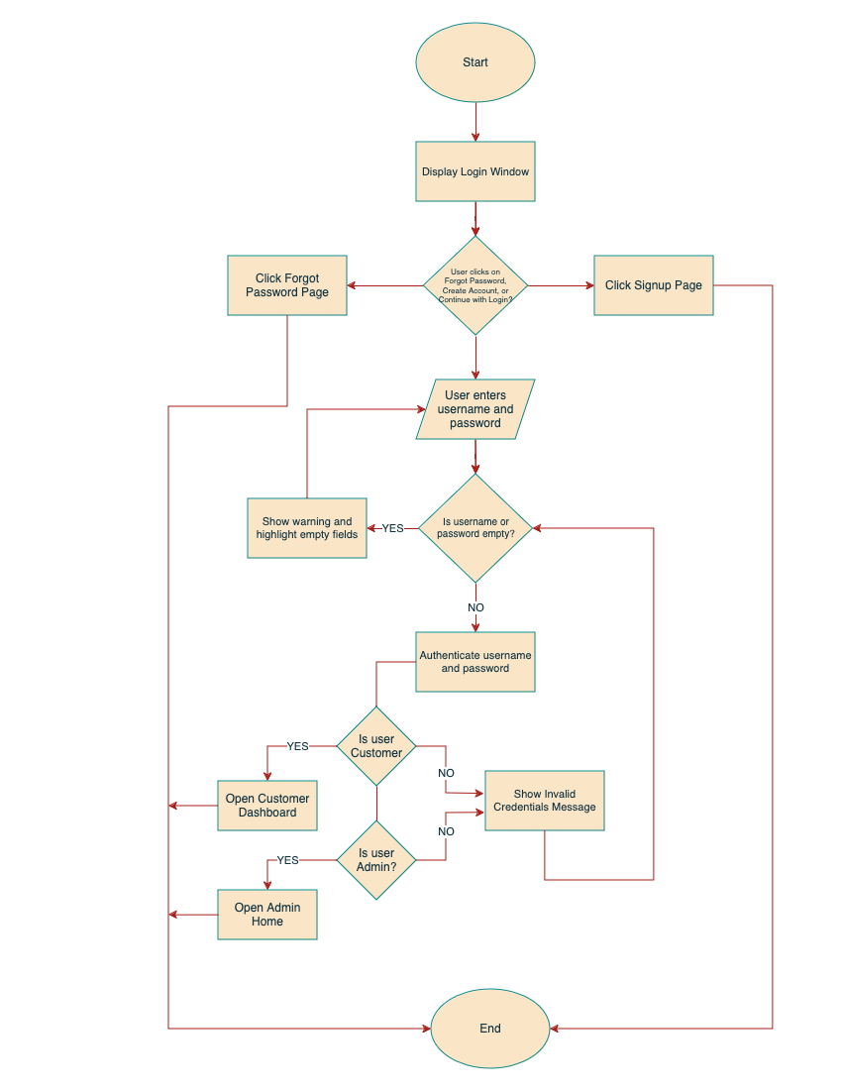**Flowchart:**

**Figure 1. Login Frame**

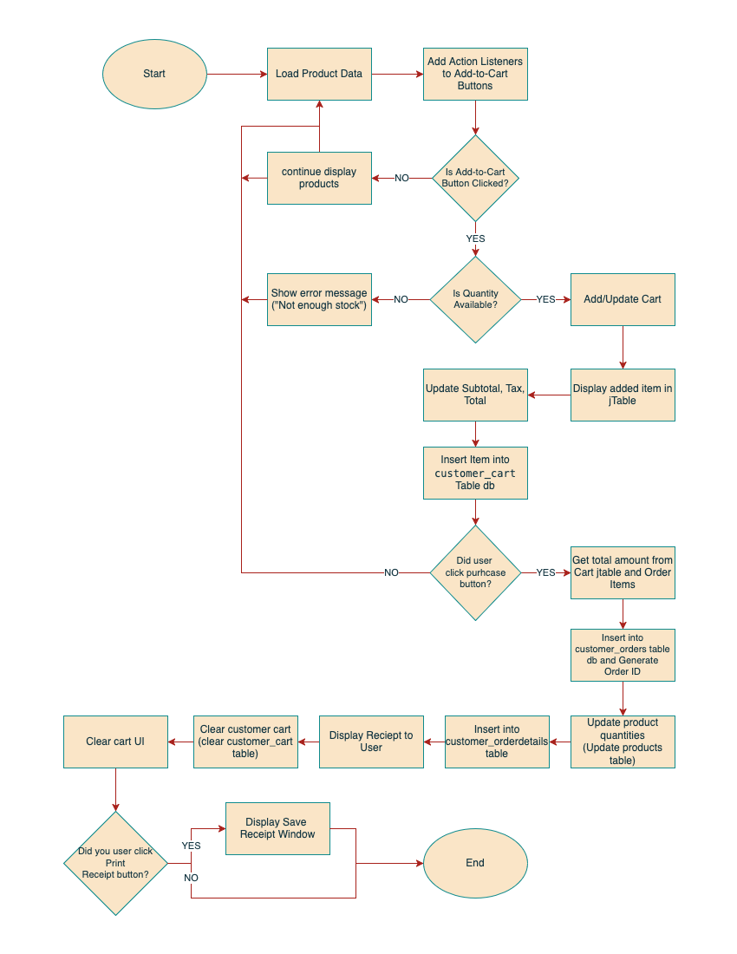

**Figure 1.1 Customer Dashboard Screen**

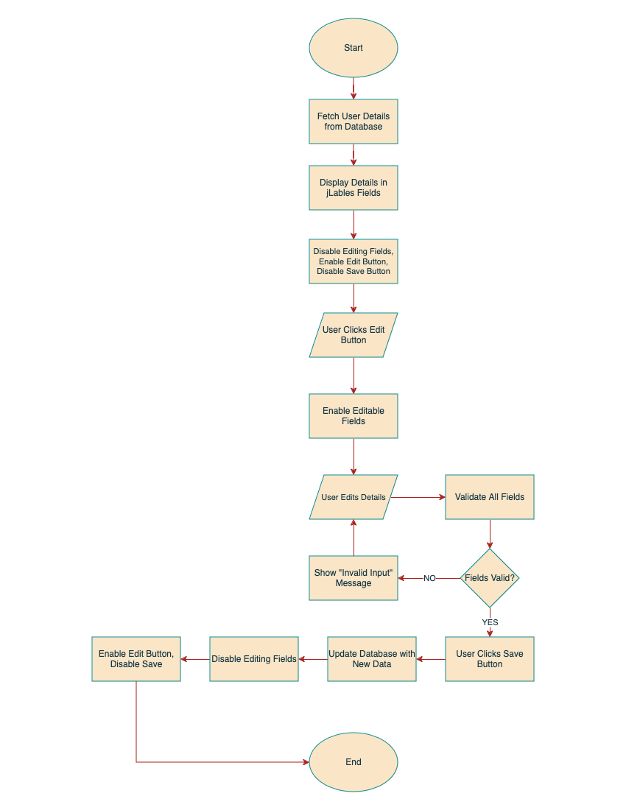

**Figure 1.2 Account Information Screen**

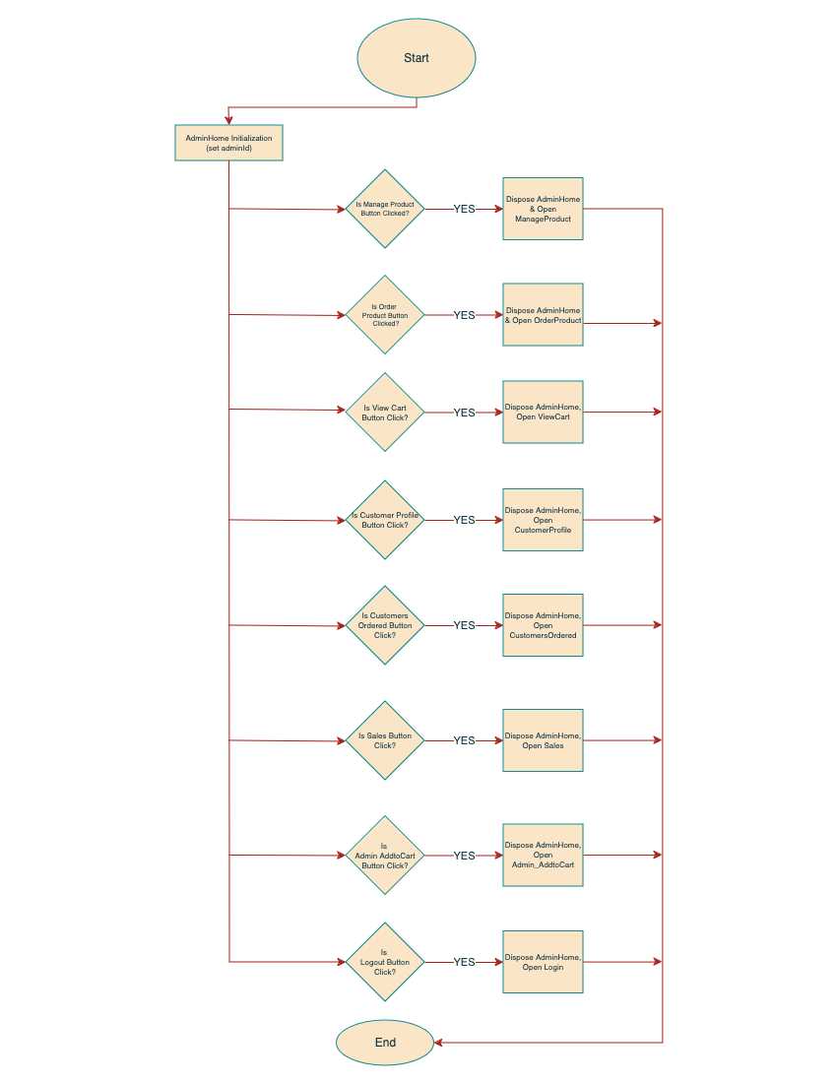**Figure 2.1 Admin Home Screen**

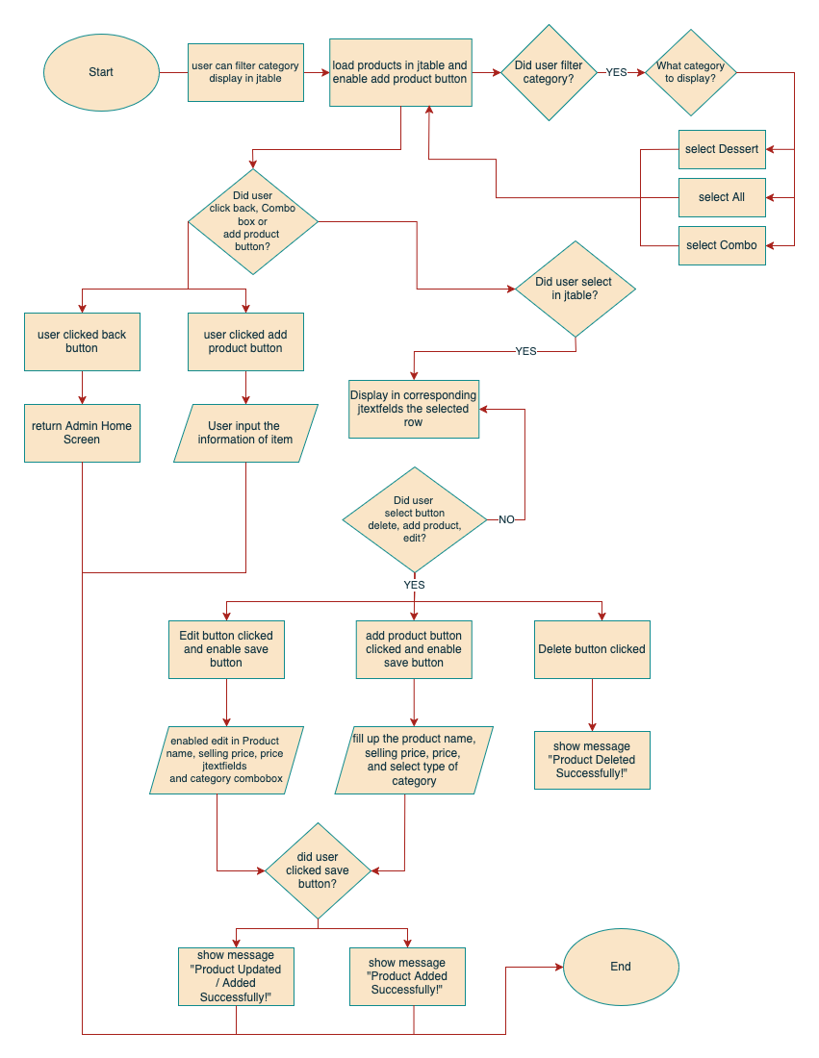

**Figure 2.2. Product Frame**

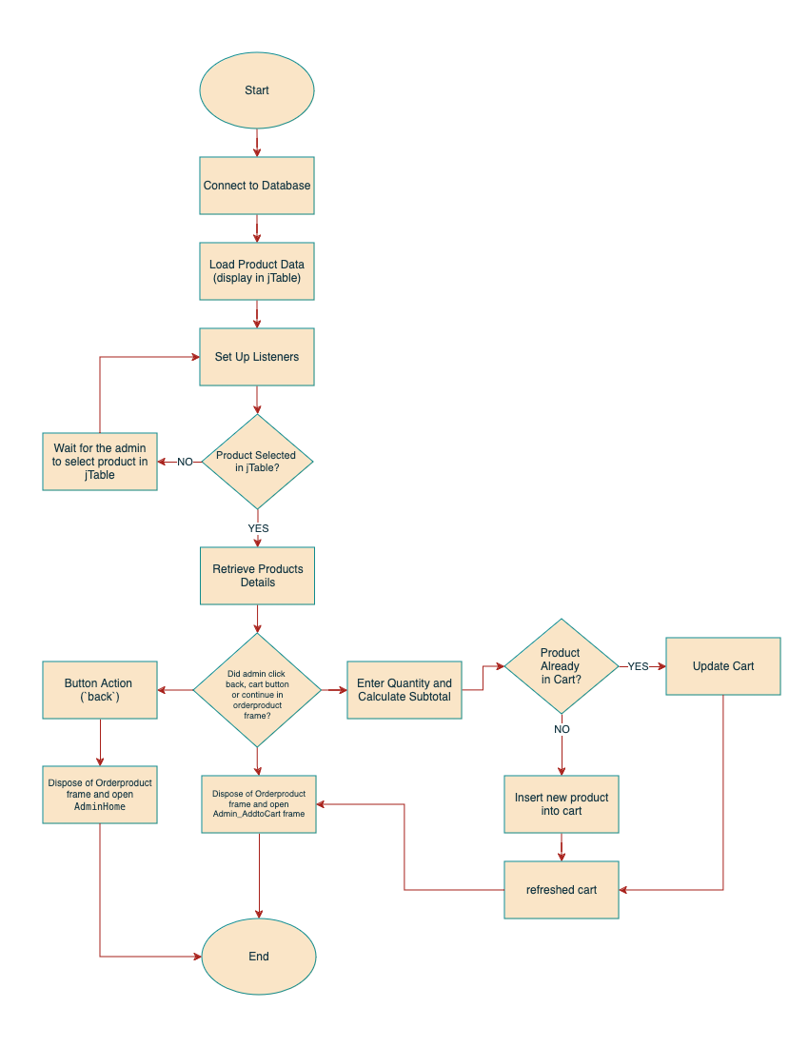**Figure 2.3 Order Product Frame**

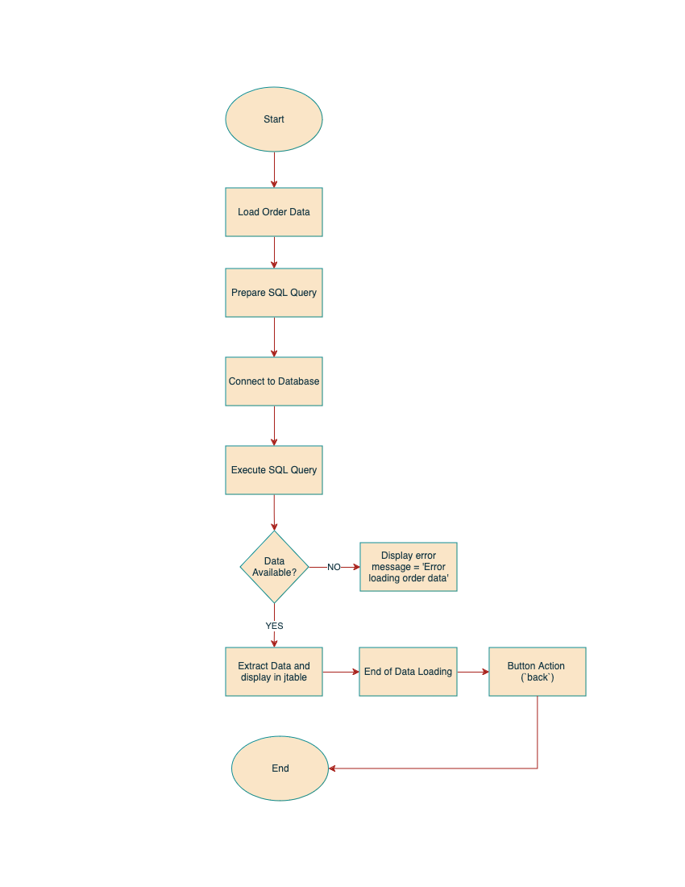**Figure 2.4 View Cart Frame**

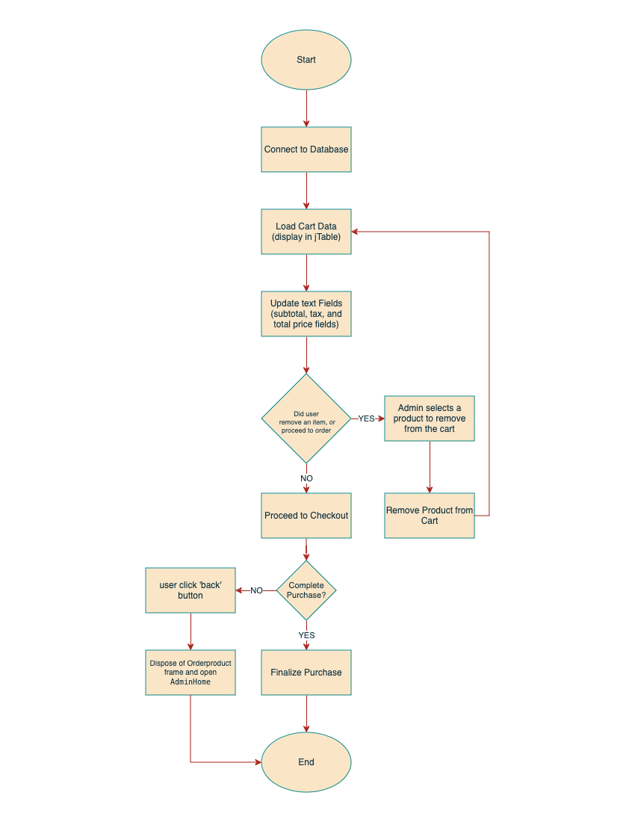**Figure 2.5 Admin Add to Cart Frame**

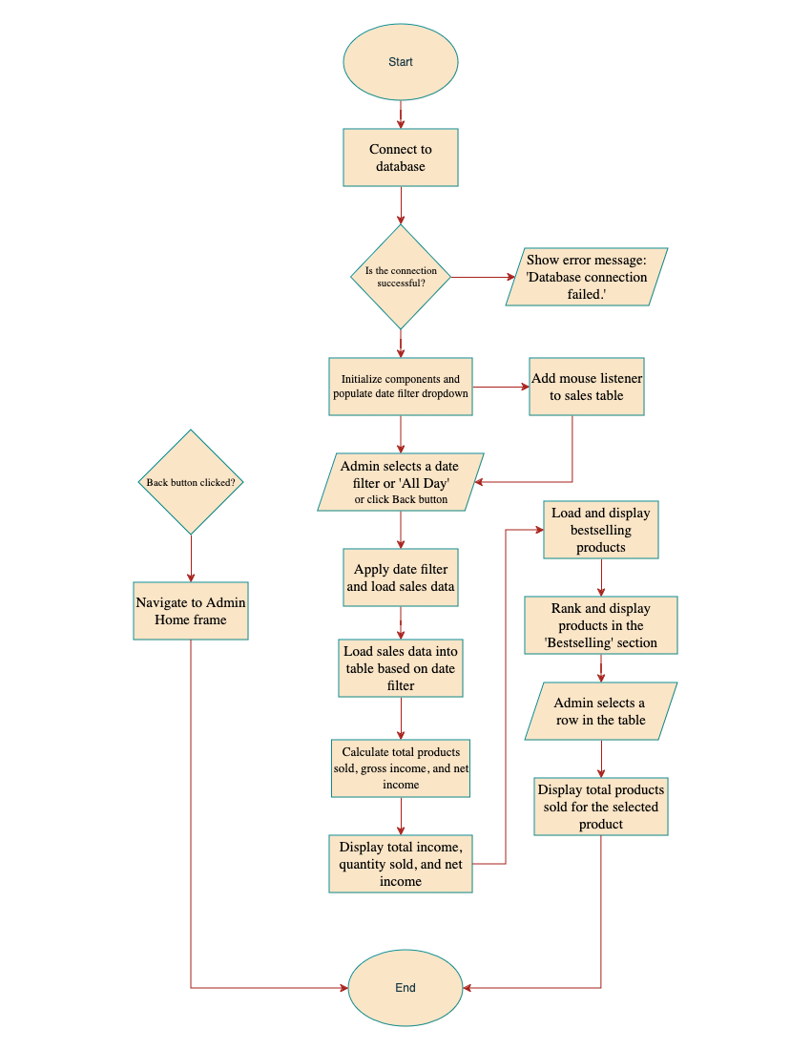**Figure 2.6 Sales Frame**

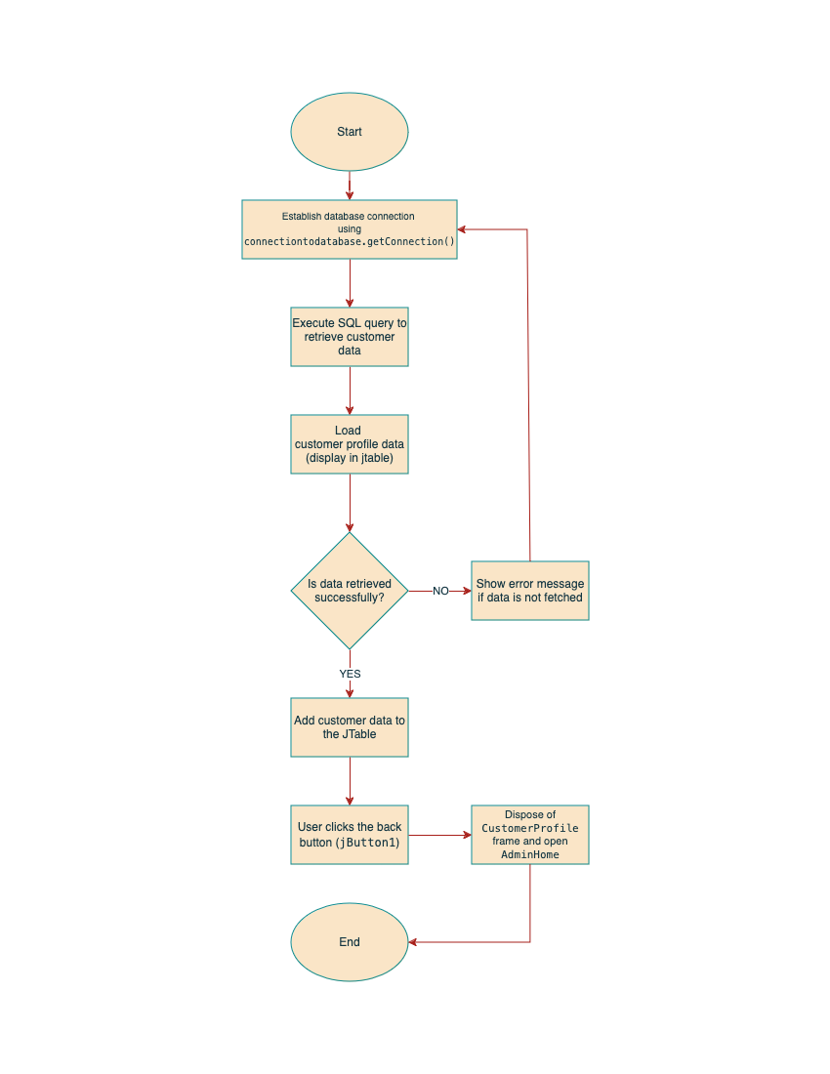**Figure 2.7 Customer Profile Frame**

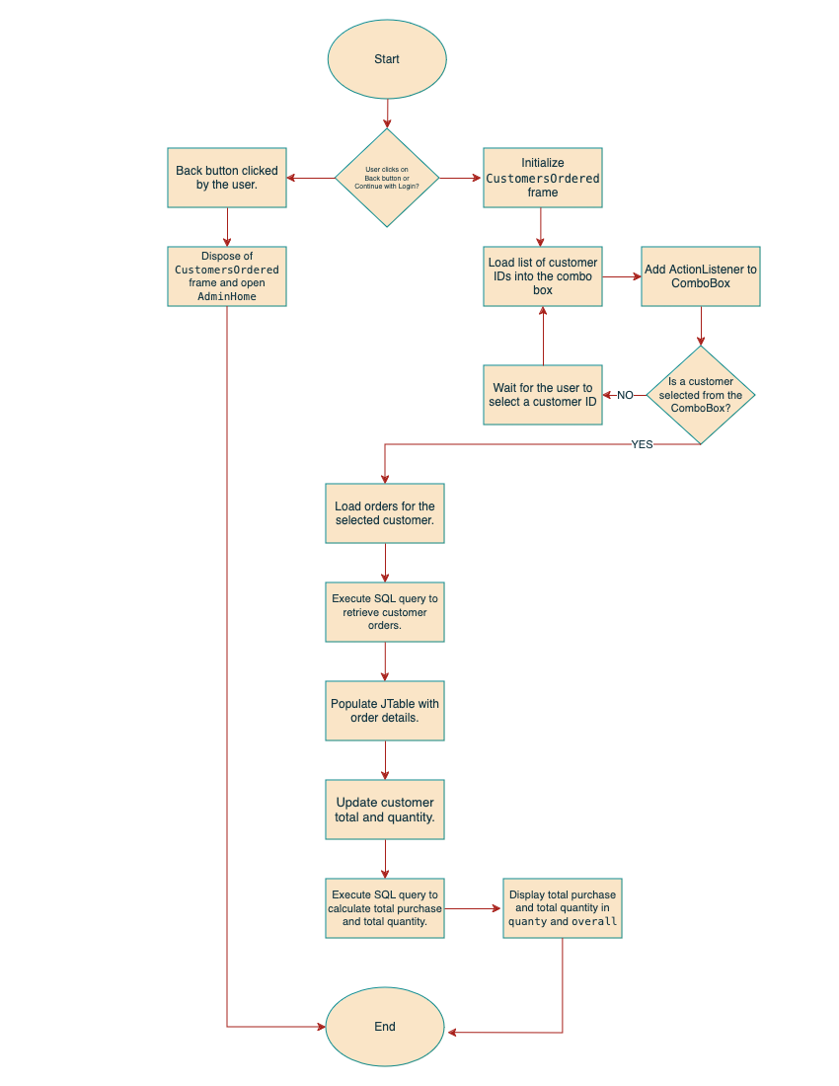**Figure 2.8 Customers Ordered Frame**

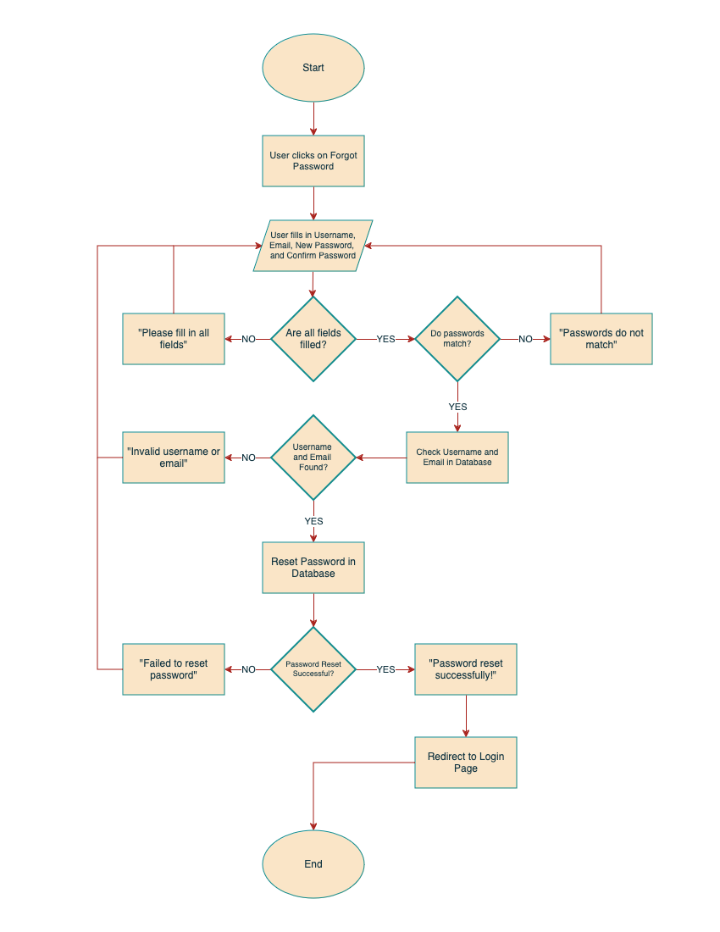**Figure 3. Forgot Password Screen**

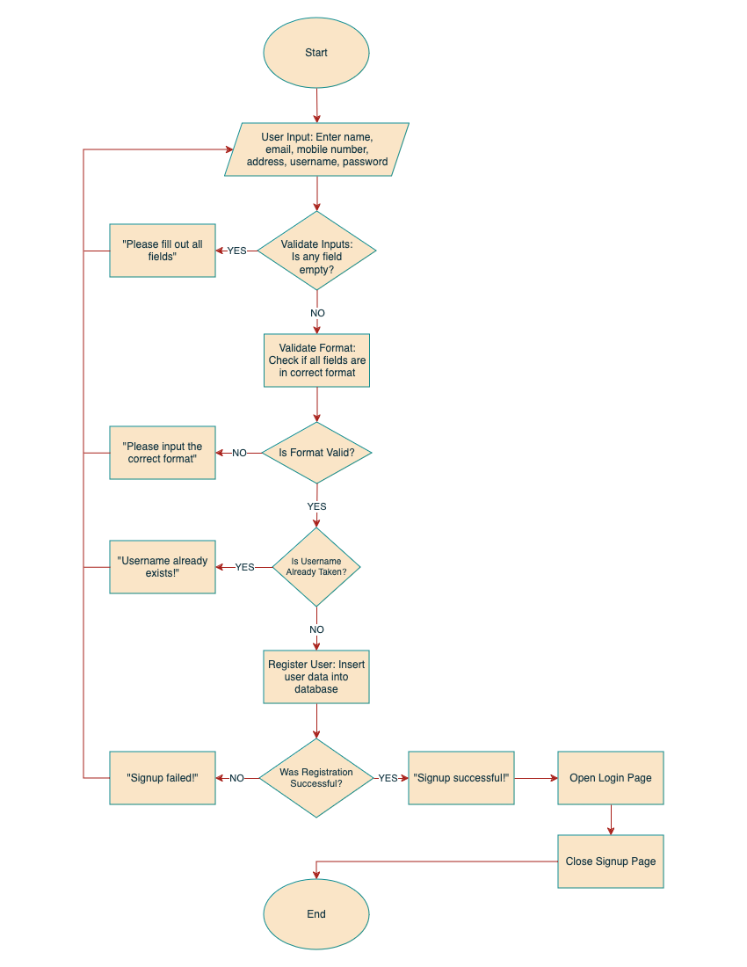

**Figure 4. Signup Screen**

**Program Hierarchy:**

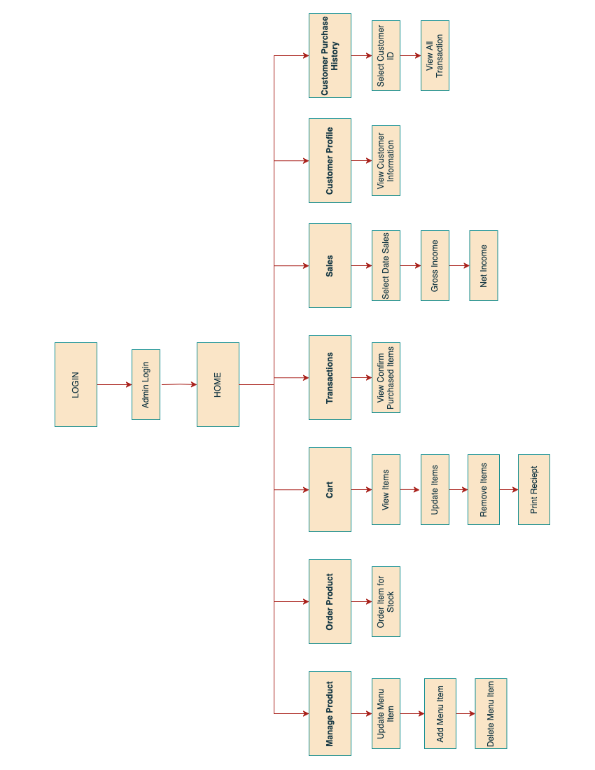

**Figure 5. Program Hierarchy (ADMIN MENU)**

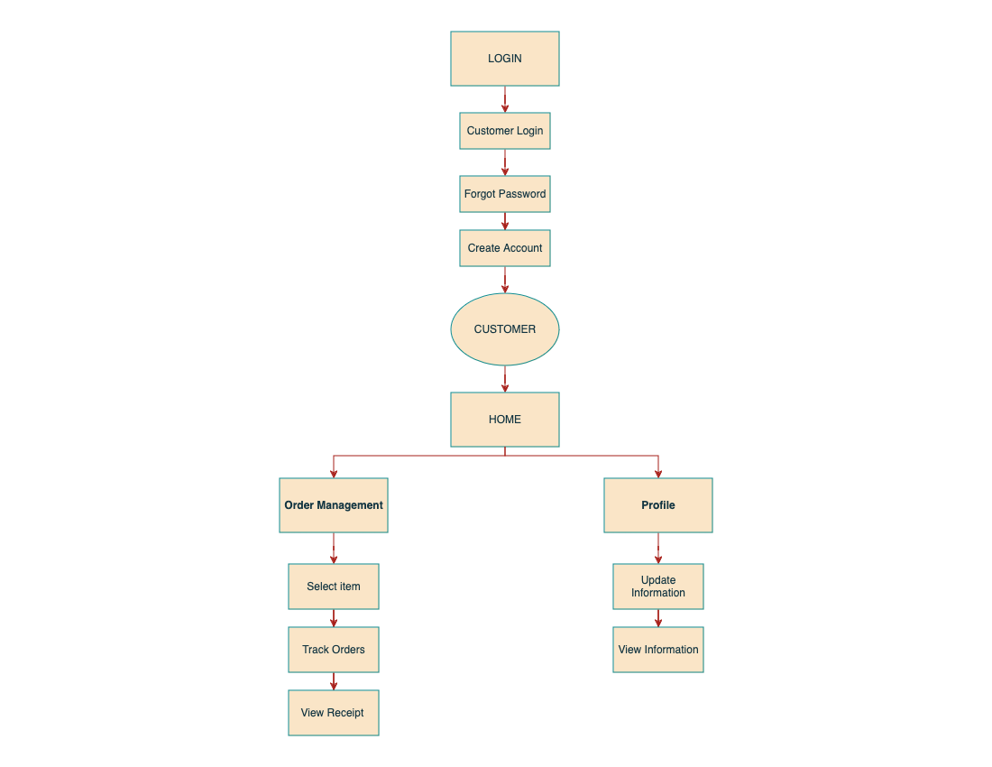

**Figure 5.1 Program Hierarchy (CUSTOMER MENU)**

**Screen Design:**

**Admin or Customer Log In**

Description: Allows the user to log in the system.

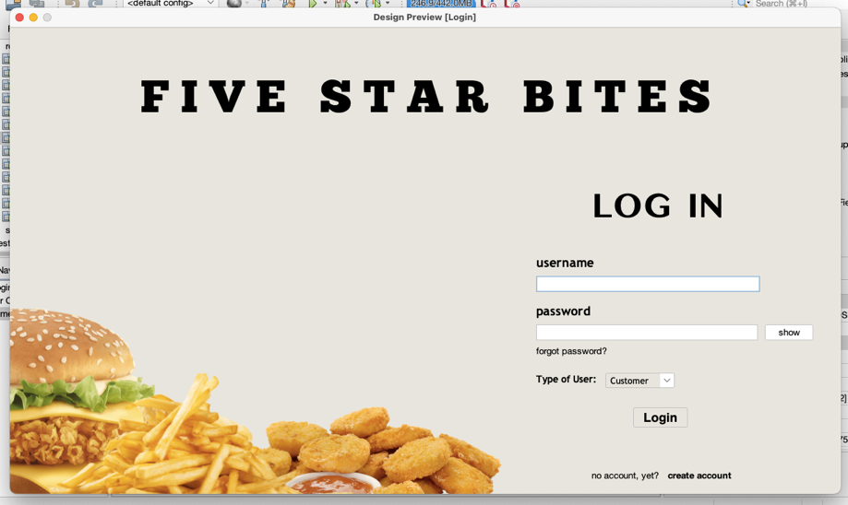

**Figure 6. Login Frame**

**Procedures:**

1. Choose Type of user: Admin or Customer
2. Enter username
3. Enter Password
4. Click Log-in button

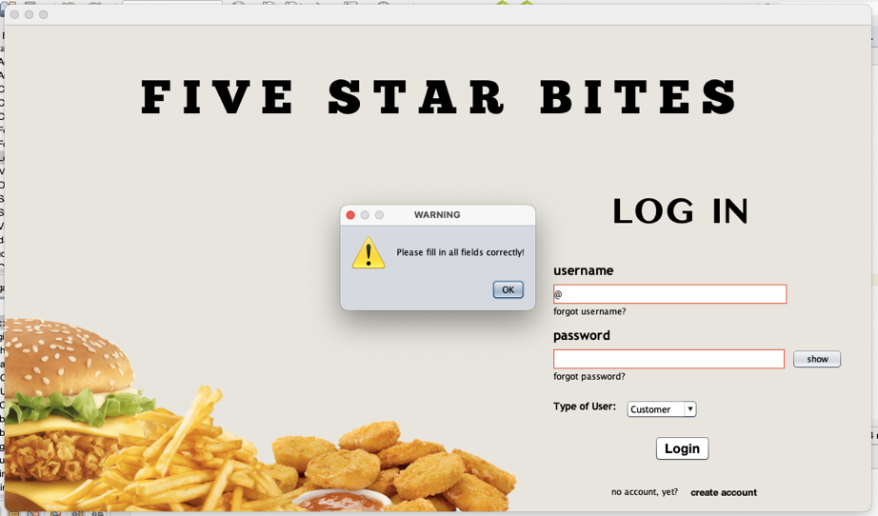 **Test Cases**

**Test Case 1. Invalid Log in form**

Scenario 1: Fill up with empty fields

Input: Click the Login with empty fields

Process: Login will not proceed

Output: The username and password are empty

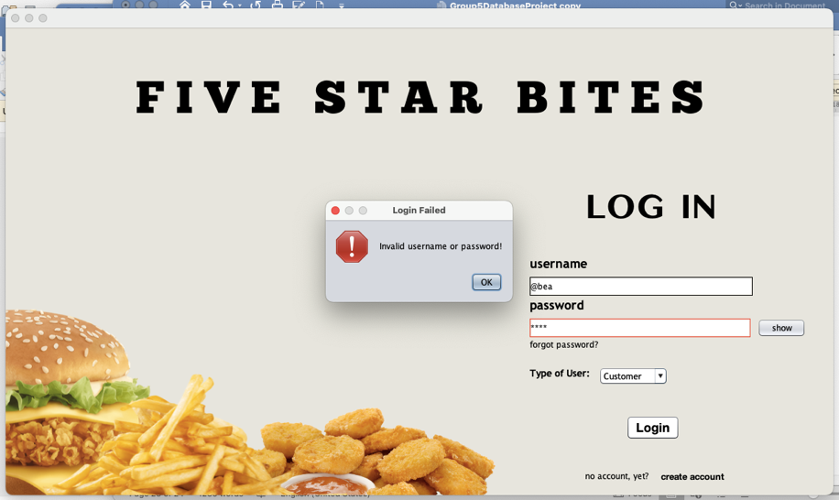

**Test Case 2. Invalid password in form**

Scenario 2: Email or Password is incorrect

Input: Wrong username or password

Process: Cannot access the system

Output: Account not found

**CUSTOMER HOME PAGE**

Description: Allow the user see the dashboard menu and after selecting an item it will go to cart table and display the items added to cart.

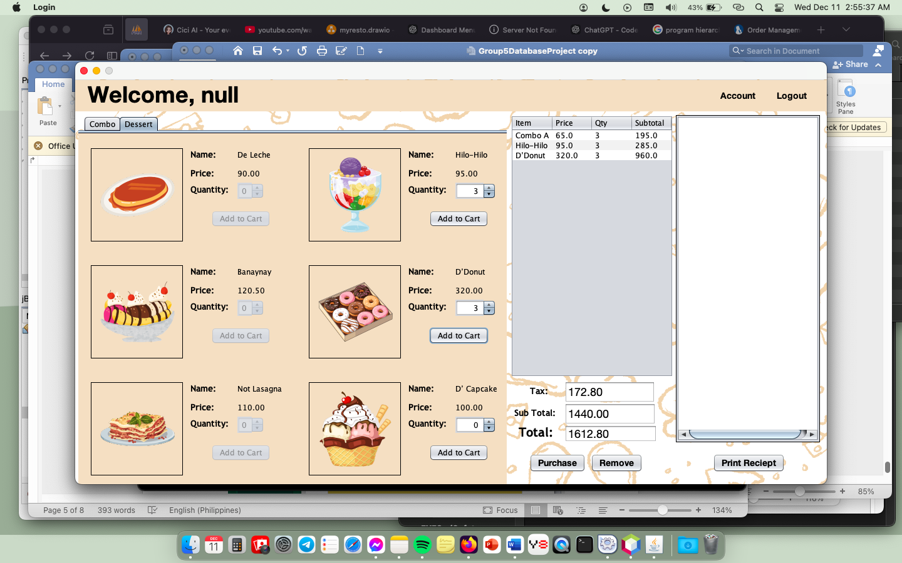

**Figure 7. Dashboard Menu Frame (Before Clicking Purchase button)**

**Procedure:**

1. Click the Add to Cart button.
2. Click the Remove button

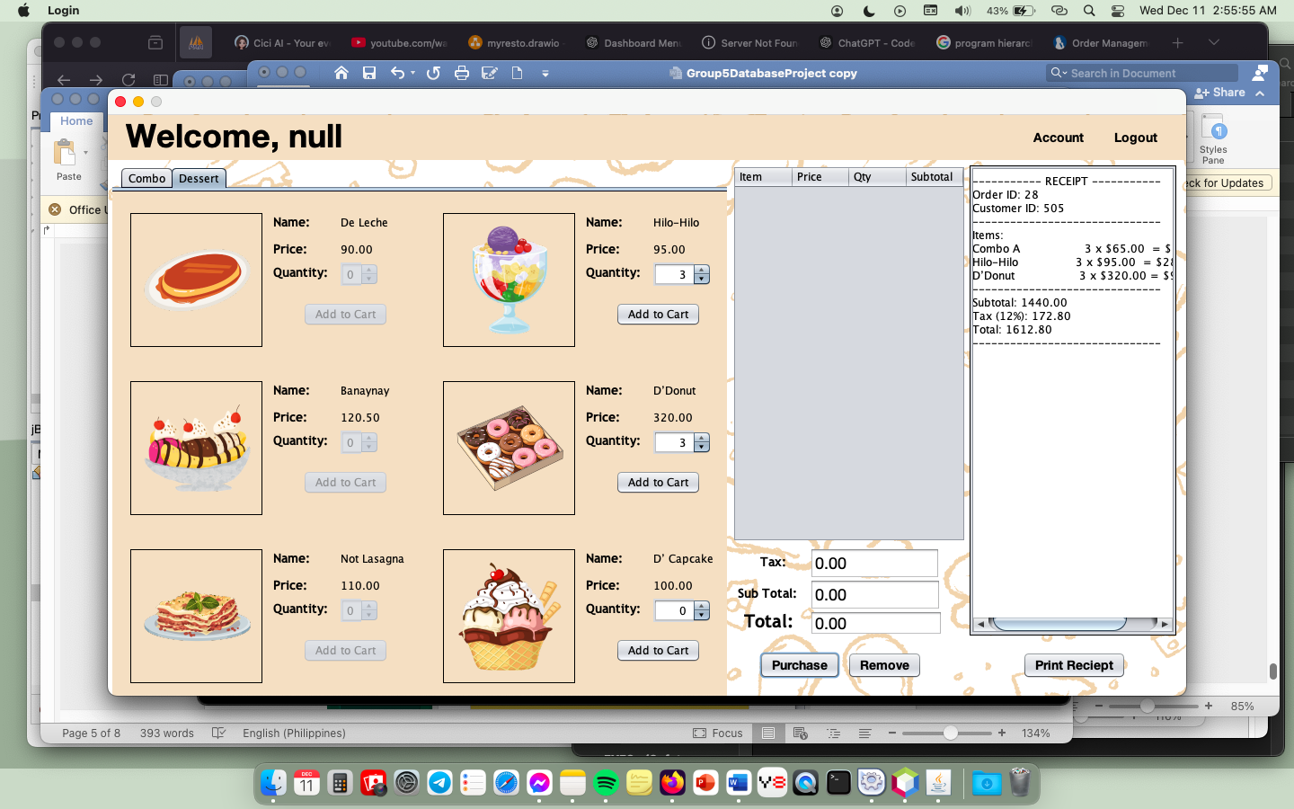

**Figure 8. Dashboard Menu Frame (Before Clicking Purchase button)**

**Procedure:**

1. Click the Purchase button.

Account Frame

Description: Allows the user to see the information of user and edit.

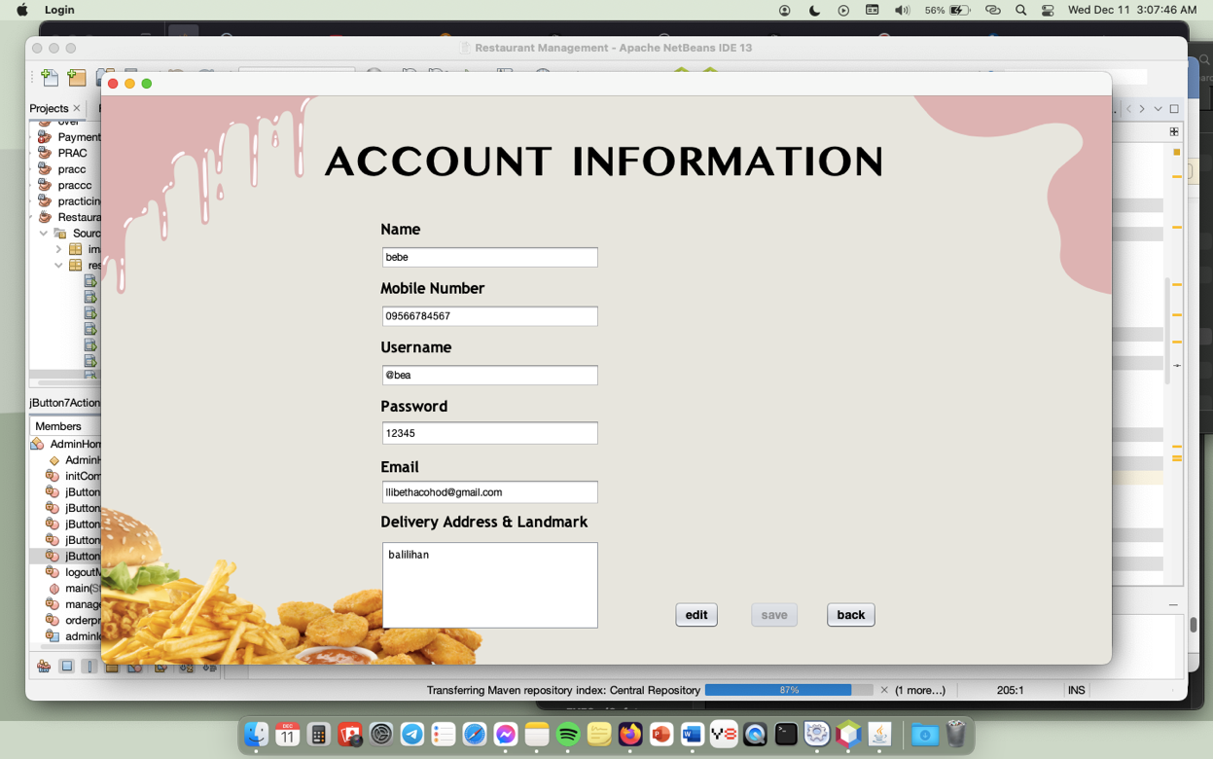

**Figure 9. Customer User Details Frame**

**Procedure:**

1. Click the Edit button.
2. Click the Save button.
3. Click Back button.

**ADMIN HOME FRAME**

Description: Allow the user to see the system admin home page.

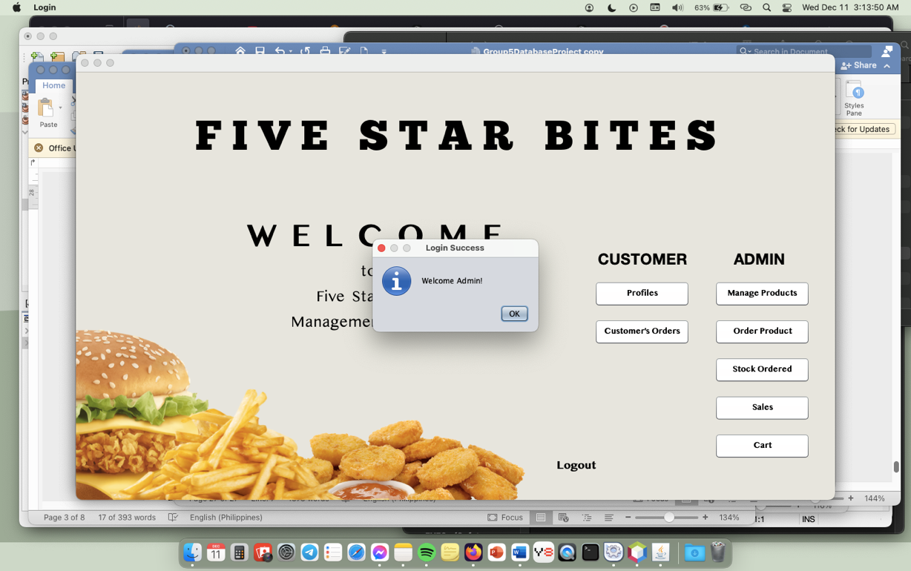

**Figure 10. Admin Home Frame**

**Procedure:**

1. Input username and email in Login Frame.
2. Choose Type of user: Admin

**MANAGE PRODUCT FRAME**

Description: Allow the user to view and edit the products to sell to customer. User can update and remove the products.

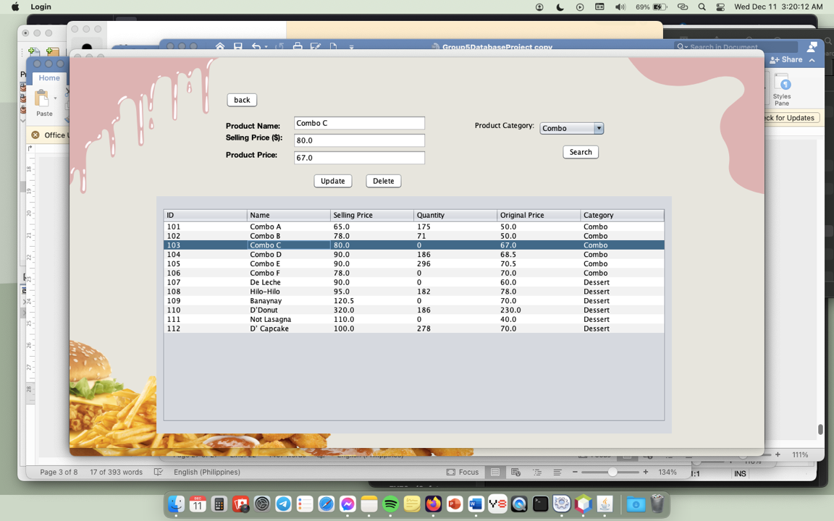

**Figure 11. Manage Product Frame**

**Procedure:**

1. Select a row you want to update the data.
2. Click update or delete for changes in the selected row.

**ORDER PRODUCT FRAME**

Description: Allow user to order an item in to increase the quantity in Manage Product Frame. User needs to input the quantity of each item then click Add to Cart button so that it will go to Add to Cart Frame and when you click Cart Button it will go to Add to Cart Frame.

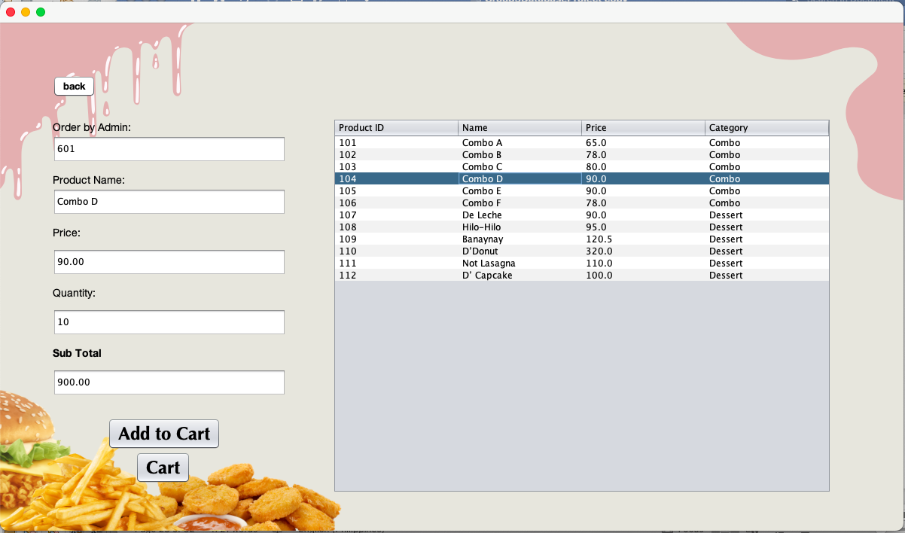

**Figure 12. Order Product Frame**

**Procedure:**

1. Select a row of product and input quantity
2. Click Add to Cart button.
3. Click Cart button to see the items in cart.

**CART FRAME**

Description: Allow user to see the items that were added from Order Product Frame. User can remove an item and can go back to Order Product Frame.

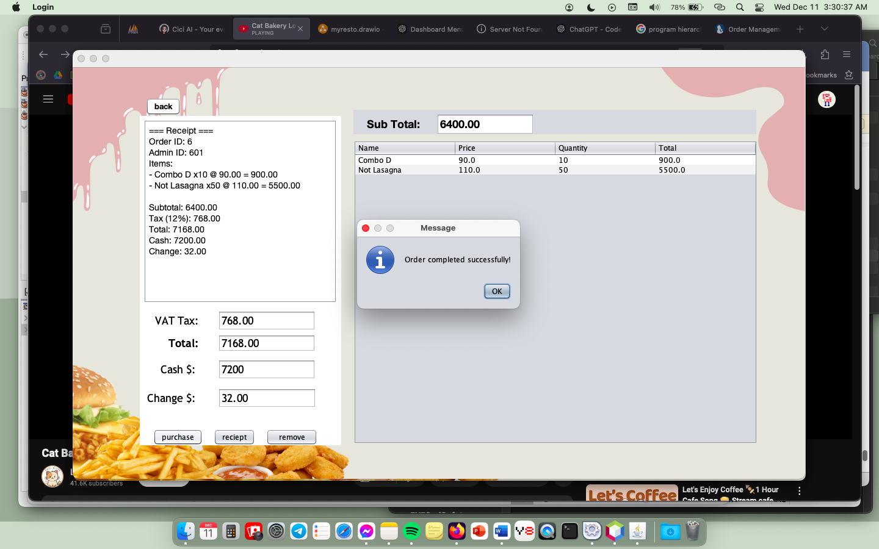

**Figure 13. Cart Frame**

**Procedure:**

1. Click purchase button for confirmed order
2. Select a row in table then click remove button for removing an item in table.

**STOCKED ORDERED FRAME**

Description: Allow user to see the transaction history of items ordered.

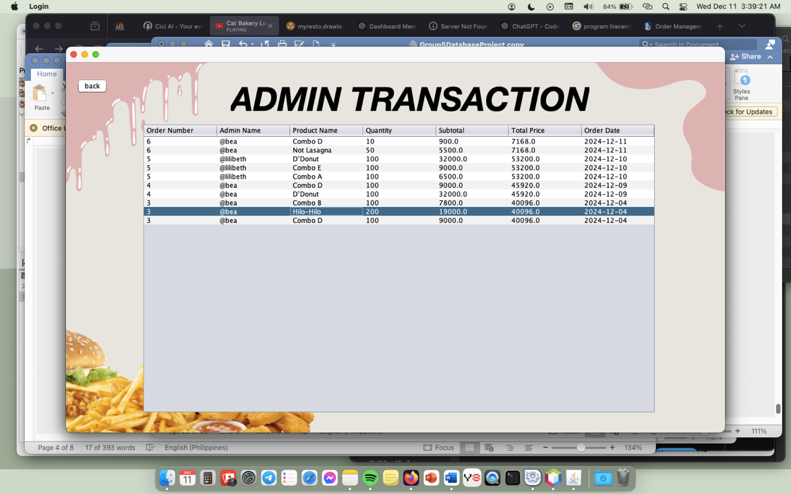

**Figure 14. Stocked Ordered Frame**

**Procedure:**

1. Click the back button to return in Admin Home Frame.

**SALES CART**

Description: Allows user to see the net income, gross income, product quantity sold, best-selling product from most to least and filter date by. In filter date by is a date where retrieve from customer_orders table in database.

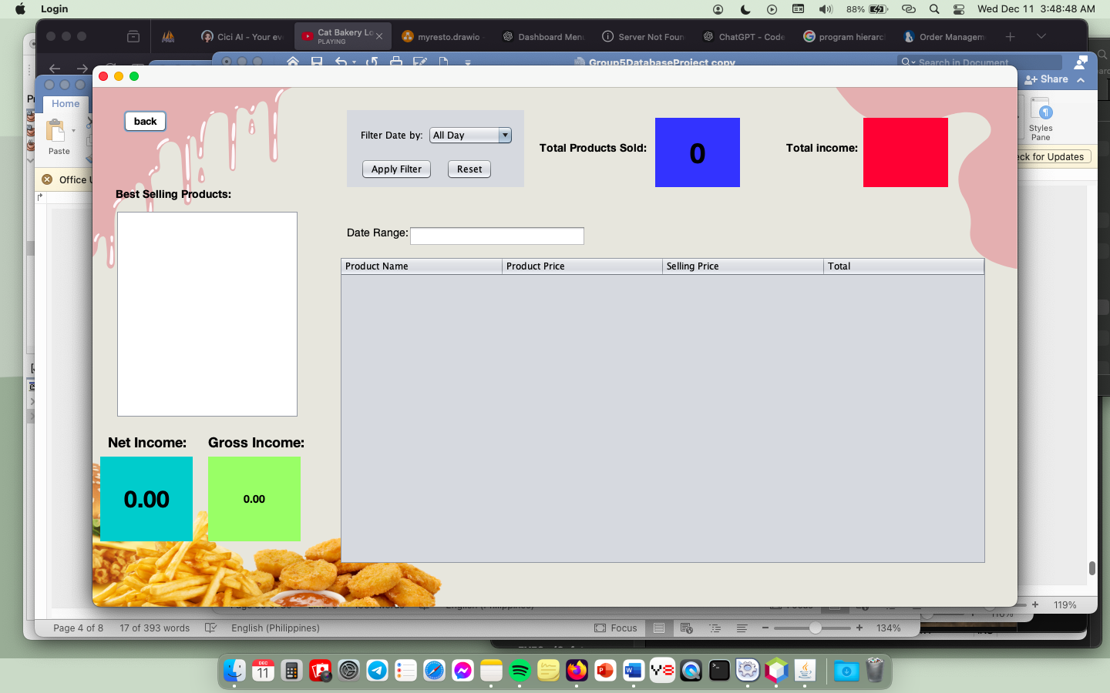

**Figure 15. Sales Frame**

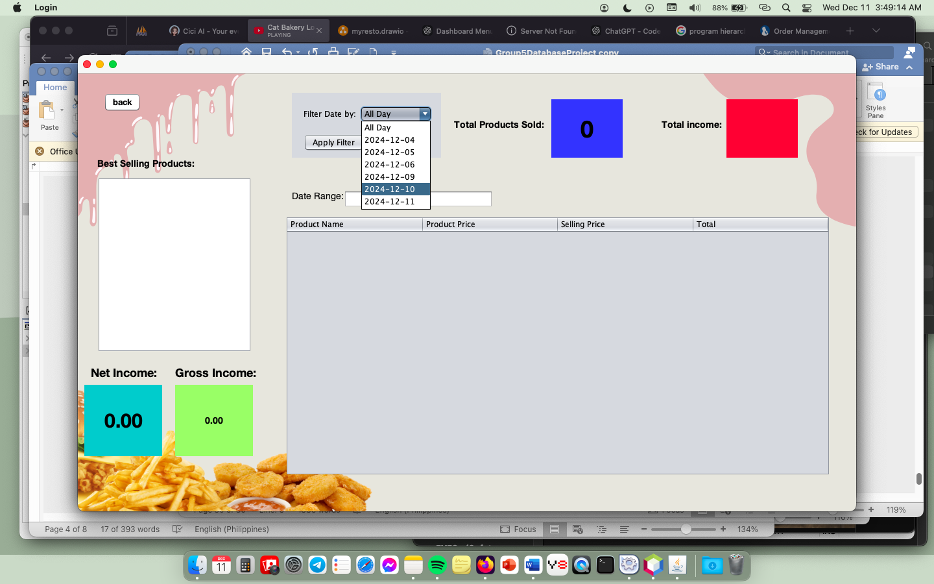

**Figure 16. Sales Frame (Selecting Filter Date by)**

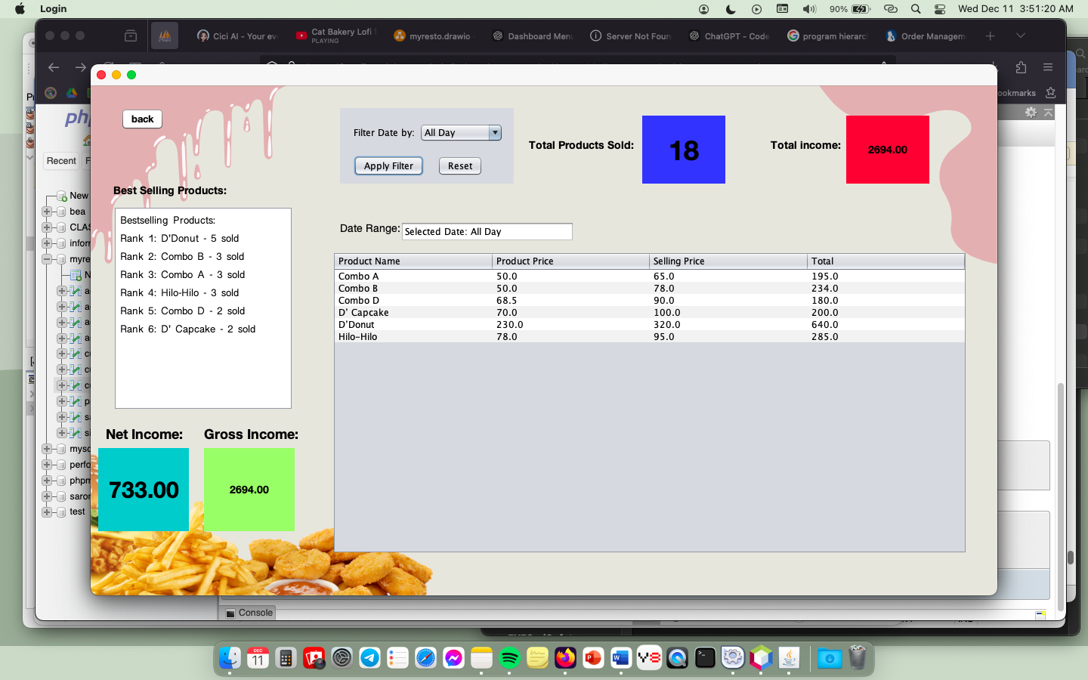

**Figure 17. Sales Frame (After selecting in Filter Date by)**

**Procedure:**

1. Select date in Combo box and click Apply Filter button
2. Click back if you want to go back in Admin Home Frame.